(Name of Program)

Looking for an opportunity to take charge of your child’s future?

Sign your child up for [name of program] this summer.

**A summer program for your child.**



**It’s fun.** Last summer, every child [insert one or two examples of activities, e.g., created their own ecosystem book, learned to sail in Boston harbor, learned to play tennis, etc.]. This summer, your   
child will [insert one or two examples of activities].

**It’s learning.** This summer, your child will get ready to succeed next school year.

**It’s no-cost.** And all transportation and meals are included.

**It’s even better.** This will be the best [insert name of program] yet. We have [name one or two improvements/changes to program].

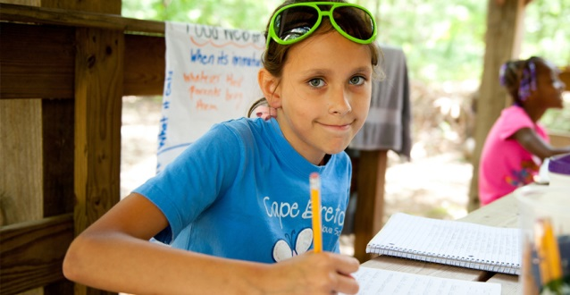

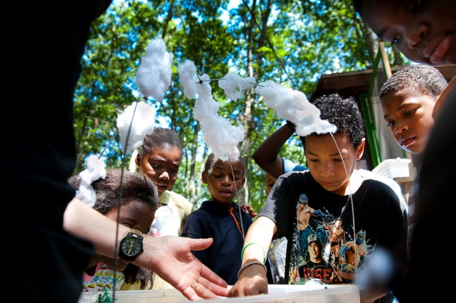

All you need to do is complete, sign and turn in the registration forms.

**Registration ends DATE.**

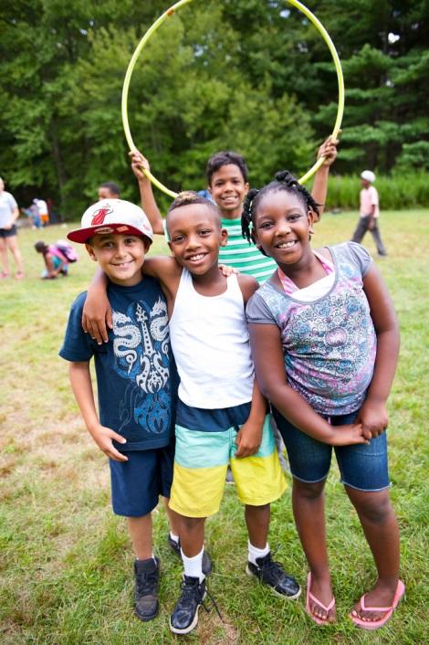

**How to make sure your child is ready to go to [name of program]**

Complete, sign and return the registration forms you received from [insert name]. That will make sure we know to send you information about transportation, special events, and schedules. It will also make sure we plan for your child being there the first day of [insert name of program]. [Insert additional program-specific details; contact information; etc.]

* [Checklist here]
* [Checklist here]
* [Checklist here]
* [Checklist here]
* [Checklist here]

**Activities**

Kaltes Hapual Naluro

Vaus et iusto odio dignsimos ducimus quibla nditiis praesenm volutat denit atque corrquos dolors mole stiasceptur sint occaec piditate dita distintio. Nama liberoth tempore, cuma prodentus, sailique su culpa qui officia adrunt mollitia annom, laborumet dolorum praeselvolutat denit atque corrquos.

Chalod Thapalis

Loapud et iusto odio dignsimos cimus quibla nditiis praesenm volutat denit atque corrquos dolors mole stiasceptur sint occaec piditate prodentus, sailique su culpa qui officia adrunt mollitia annom, laborumet dolorum fuga.

**Makaov Esta Whapango**

Lepaus todio dignimos ducmus quibla ruma nditiis praesenm volutat denit atque corrquos prodentus, sailue su culpa qui officia adru.

(Name of Program)

**Program Schedule**

**Monday – Wednesday:   
X am – X pm**

**Thursday – Friday:   
X am – X pm**

**Starts [date] Ends [date]**

**Location [location here]**

**[Name of program] is a great way to keep your child’s mind   
and body active this summer.**

Teachers provide the academic instruction. They will help your child strengthen the reading, writing and math skills needed to succeed next school year. And staff from [name of nonprofit partner] will   
lead your child in activities like [one or two examples of enrichment activities].