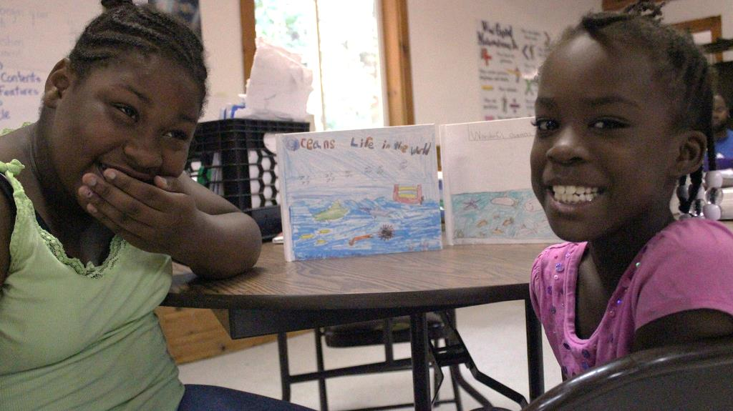

[Name of program] is a [*insert quick text about your program*].

**Registration ends Date.**

Mail Panel (Optional)

**Ready for a summer filled with fun activities   
while getting ready for the next school year?**

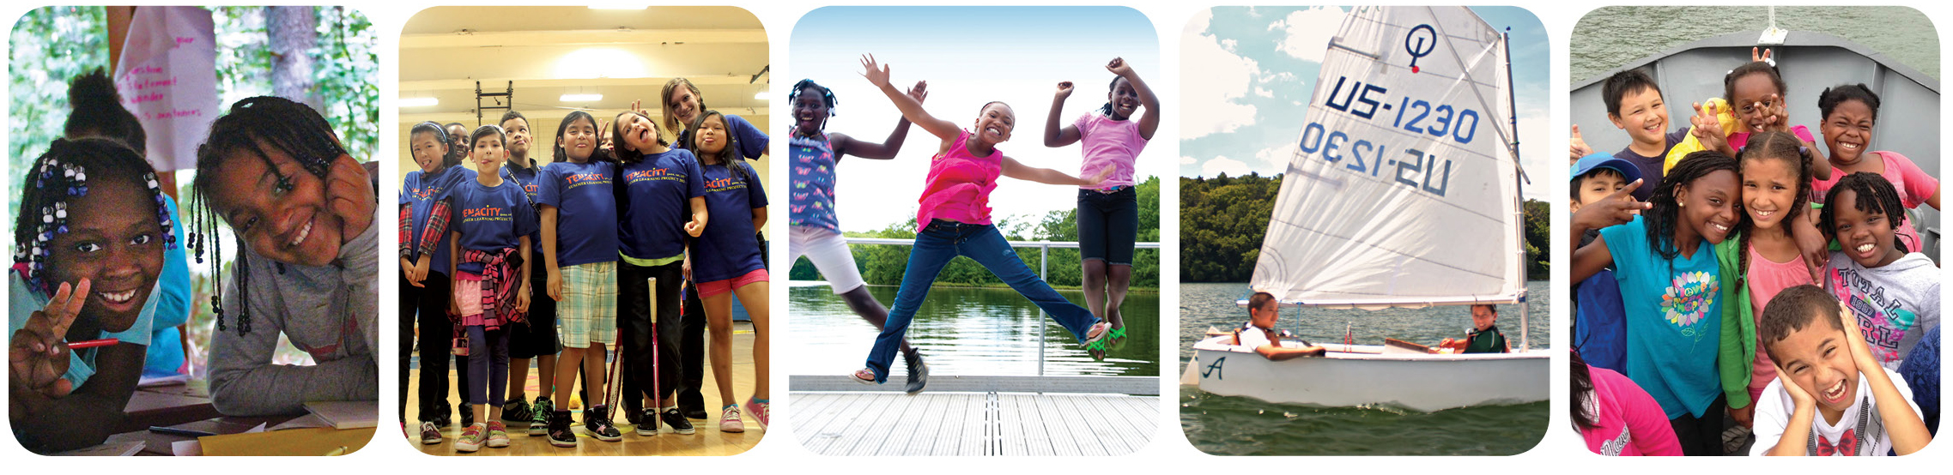

**[Personalized Message]**

All you have to do is fill out the registration forms.

**Join us this summer.**