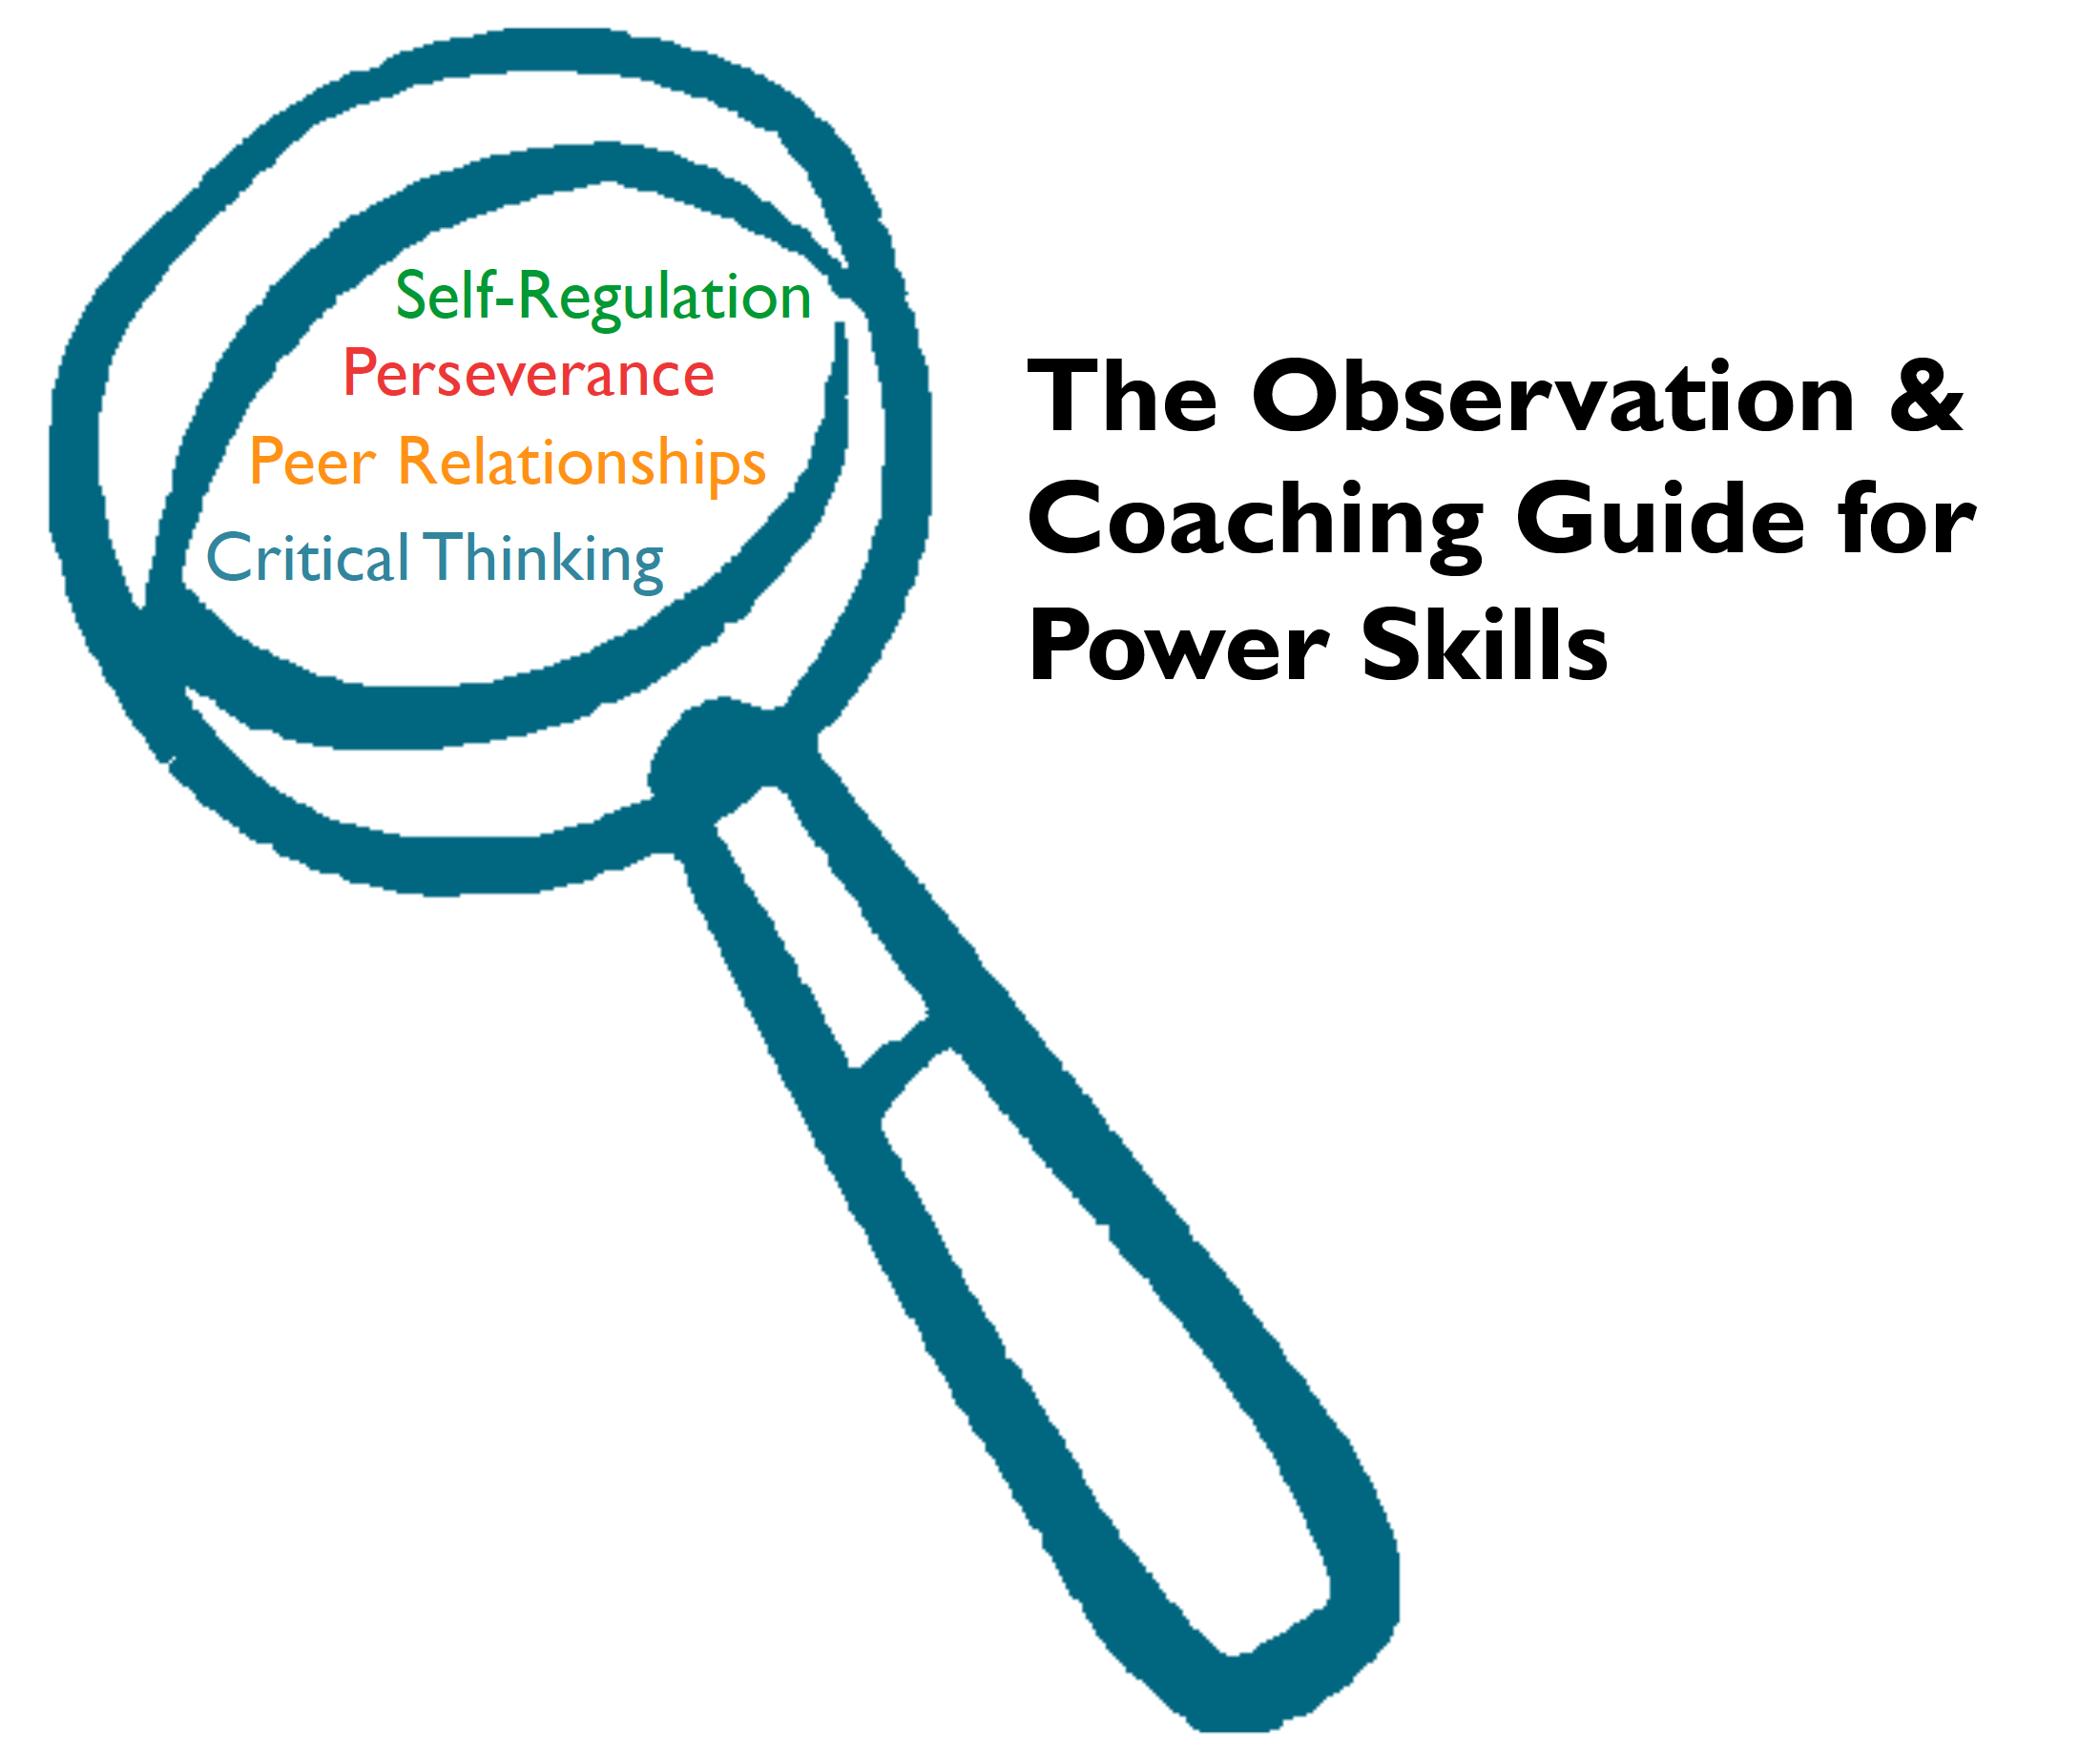

The Observation and Coaching Guide for Power Skills is not available for public use or distribution.

© 2009-2015 PEAR - Program in Education, Afterschool, and Resiliency

All rights reserved. No part of the material protected by this copyright notice may be reproduced or utilized in any form or by any means, electronic or mechanical, including photocopying, recording, or by any information storage and retrieval system, without written permission from the copyright owner.

Table of Contents
Introduction to the Observation and Coaching Guide for Power Skills
Glossary of Terms – pg. 4
The Observation and Coaching Guide for Power Skills – pg. 5
Observation Protocol – pg. 6

Power Skills:

Self-Regulation – pg. 6

Perseverance – pg. 8

Relationships – pg. 10

Critical Thinking – pg. 12

Coaching Resources:
The Rating Sheet – pg. 14
Coaching Strategies to Keep in Mind – pg. 16
Leverage Leadership Coaching Structure – pg. 17

Glossary of Terms

Glossary of Terms
Power Skills | In this observation protocol, there are four Power Skills (Self-Regulation, Perseverance, Relationships, and Critical Thinking). Each Power Skill describes an overall construct that is related to the quality of socio-emotional skill development in summer programming.
Rubric | The rubrics have a 4-point scale and are used by the observers to help assess the socio-emotional quality of the program they are observing. Each level has an explanation of the key indicators that help the observer/coach choose a rating.
Learning Environment | Because summer programs take place in a range of settings (e.g., museums, fields, gardens, cafeterias, classrooms, community centers, libraries, etc.) we will be using the term “learning environment” to describe the setting where the program activities are enacted.
Facilitator | There are many professionals that lead activities in summer settings; therefore, we will use the term facilitator when referring to the person who is facilitating the activities in a program (teacher, coach, facilitator, group leader, counselor, etc.).

Introduction
The Observation and Coaching Guide for Power Skills was developed to provide a systematic way of assessing quality in a range of informal summer programs.
The Observation and Coaching Guide for Power Skills
This guide is made up of four rubrics, which were developed by PEAR. Each rubric is based around one of four Power Skills that are currently in use in Boston’s Summer Learning Project (SLP).
These rubrics describe critical, key indicators of program quality in OST environments. A detailed description of each rubric, including specific advice and examples for the observer, is included in the guide. Each rubric is scored on a 4-point scale of increasing quality, using detailed descriptions to guide observer ratings. In order to justify their ratings, observers write detailed evidence based on field notes they take from the observations and the language from the rubric, allowing programs to consider both the ratings and the qualitative data when giving feedback to their staff.
Using the Guide
The Observation and Coaching Guide for Power Skills was designed to be a self-assessment observation tool for administrators and staff. When used for program quality improvement, we suggest debriefing the activities or lessons with staff and having them join in the process of coaching strengths, identifying weaknesses, and developing next steps for improving quality summer programming.

Conducting an Observation
Before the Observation
- The guide should be used in structured activity during summer programs that have preplanned activities, with designated staff, and some curricular goal, whether they be short or long term.
During the Observation
- Observers will need to take low inference notes (notes in which you are simply observing what is happening, not on making inferences or judgments) during the observation, so they can capture specific details from the activity, such as quotes, examples of how students are reacting, etc.

Self-Regulation
Description: Self-regulation, or emotional control, is the constructive ability to manage your emotions in a way that they do not alter your behavior. Self-regulation is the capacity to control and alter one’s behaviors. It is the process by which individuals attempt to constrain undesirable urges and present only behaviors that are congruent to a set of social standards and personal goals. Facilitators should set up activities in a way that students can be successful practicing self-control, thinking before they act, and regulating their emotions.

Elaboration: Someone who struggles with self-regulation is likely to be easily distracted, have a heightened response to stimuli (people and situations), have issues with anger management, and under performs in school. Someone who self regulates resists distractions, manages frustrations, focuses attention, and persists at difficult tasks.

Strategies:
Set Behavioral Standards: Set up standards of expectations early to give students clear guidelines of what is expected of them and their behavior. Behavioral standards should be visual for students, for example, in the form of posters with expectations.
Rituals: Rituals are important for students who struggle with self-regulation. By having a pattern of behavior that is expected, for example the same beginning and ending activities in a class every week, students know what to expect and get into a rhythm of behavior, which helps to regulate their behavior and cue their brains to the unique.
Calming Rituals/Space: Rituals for when a student’s behavior may be escalating and would help set expectations for the student on when and how to regulate their own behavior. Provide a calm, comfortable space in which students can calm down.
Calm Environment: Provide students with a calm environment to naturally enforce self-regulation and ease this process for students. A calm environment could include setting expectations of using quiet voices to lower volume in the room and therefore creating a calmer atmosphere. Have posters in the room of calming methods, e.g. deep breathing exercise. Work calming techniques into a lesson plan. If students struggle transitioning from a more active task back to being at their seats, try a group cool-down to get them back to a calmer state. Communicate clearly and firmly when trying to calm a student.
Facilitator Modeling Appropriate Responses: Make sure to model expected behavioral responses. For example, not yelling when students misbehave, time warning before transitions, etc.
Goal Setting: Help students set small, measurable, and attainable goals. Provide students with positive reinforcement through praise when on task and working towards their goal(s). Allow students to set their own goals to help them to regulate their own behavior in order to reach these goals.
Self-Regulation Rubric
Evidence Absent | Inconsistent Evidence | Reasonable Evidence | Compelling Evidence
There is little or no evidence that facilitators are using strategies that allow students to build skills in self-regulation. | There is limited evidence that facilitator are using strategies that allow students to build skills in self-regulation. | There is clear evidence that facilitator are using strategies that allow students to build skills in self-regulation. | There is consistent and meaningful evidence that facilitator are using strategies that allow students to build skills in self-regulation.
1 | 2 | 3 | 4
Facilitator doesn’t use any strategies to build self-regulation.  OR  Facilitator uses a strategy in a negative way.  For example, the facilitator might be trying to create a calm environment, but in the process does so in an intimidating or authoritarian manner. | Facilitator uses 1 (maybe 2) strategies to build self-regulation, but not consistently or effectively.  For example, the facilitator has a strong closing ritual in place, but it takes so much time and staff preparation that it often gets cut short or skipped. | Facilitator consistently and effectively uses 1 (maybe 2) strategies to build self-regulation.  For example, the facilitator has calming space for students that is used when students are upset and need a break. | Facilitator consistently and effectively uses 2 or more strategies to build self-regulation.  For example, the facilitator has students set goals and monitor their progress, has a morning opening ritual, and has a calming space that students utilize.

Perseverance
Description: Perseverance is the ability to continue with a task despite coming across obstacles and challenges. This involves trying again after failing to solve a problem; working hard to achieve goals even if things get in the way; continuing to work on assignments that take longer than expected; and continuing routine activity in the face of adversity.

Elaboration: A lack of perseverance is not the same as laziness. Someone who struggles with perseverance may abandon previous goals when presented with new ideas, projects, or set backs, have difficulty maintaining focus on long-term goals, quit when struggling at a sport or game, or appear apathetic, lazy, or lethargic. Someone who perseveres tries again after failing to solve a problem, works hard to achieve goals even if things get in the way, continues to work on tasks that take longer than expected, and tries to be social even when he or she feels lonely.

Strategies:
Culture of Hard Work: Create a culture of hard work in the learning environment. Create a norm of pushing through to overcome challenges and not giving up. For example, frequently saying statements such as “Remember, we work hard at this program” or having the culture of hard work included in a morning mantra or mission statement will help to build this culture. Let students know that it is normal to struggle, feel confused and make mistakes – it’s all part of learning!
Frame Feedback Positively: Teach students the importance of optimism and positive self-talk For example, “This was a challenge that you can overcome and next time I know you can do better” not “You failed at this task.”
Track Progress: In addition to talking about the importance of effort, it is important to track and measure this with students.
Rewarding Effort: Reward effort more than academic achievement to put a focus on trying hard and persevering, not just intelligence.
Summer Long Projects: Have students take part in summer long projects to reinforce the importance of persevering over both challenges and long time frames, e.g. overcoming boredom.
Integrate Perseverance Language: Regularly use language related to perseverance, such as, “stick with it,” “drafts,” and “editing.”
Pacing Partners: Pair students together with people that can challenge them, but isn’t so advanced that the student feels like obtaining that level of achievement is unrealistic.
Attendance Ritual: Develop a ritual to celebrate students attending the program each day. This shows that you are valuing them sticking with the program, and that showing up is an important part of working hard to complete goals.
Perseverance Rubric
Evidence Absent | Inconsistent Evidence | Reasonable Evidence | Compelling Evidence
There is little or no evidence that facilitators are using strategies that allow students to build skills in perseverance. | There is limited evidence that facilitators are using strategies that allow students to build skills in perseverance. | There is substantial evidence that facilitators are using strategies that allow students to build skills in perseverance. | There is consistent and meaningful evidence that facilitators are using strategies that allow students to build skills in perseverance.
1 | 2 | 3 | 4
Facilitator doesn’t use any strategies to build perseverance.  OR  Facilitator uses a strategy in a negative way.  For example, the facilitator has a high expectation of challenge, but the level of the challenge is the same for all students. Making it too challenging for some and too easy for others. | Facilitator uses 1 (maybe 2) strategies to build perseverance, but not consistently or effectively.  For example, the facilitator rewards effort of only some students in the group that perform better than other students, while some students who struggle more are not rewarded for their effort. | Facilitator consistently and effectively uses 1 (maybe 2) strategies to build perseverance.  For example, the facilitator has a weekly challenge problem the students need to solve. | Facilitator consistently and effectively uses 2 or more strategies to build perseverance.  For example, the facilitator had the students create a business plan throughout the summer. The facilitator uses rewards for students sticking with it when things are challenging.

Peer Relationships
Description: Positive relationships with peers involves a student having supportive and respectful connections with friends and classmates. Peer relationships are different from Child-Adult relationships in that they are often more egalitarian. Peer relationships, if positive, can provide a child with opportunities for learning cooperation, sharing, compromise, empathy, conflict resolution, assertiveness and fun. Facilitators encourage and validate efforts by the students and create a warm atmosphere for learning.

Elaboration: Signs of a negative relationship include bragging, put-downs, fighting often, gossiping, and bullying. Positive relationships are characterized by respectful interactions between students such as students’ willingness to sit in close proximity with each other or students working cooperatively, sharing, respecting differences, sticking up for each other, being helpful, being honest, and listening to each other, especially during a fight.

Strategies:
Team Building: Notice if there are specific social skills your students find particularly challenging and actively encourage these. This could be sharing, teamwork, compromising etc. You can build these skills through team building activities.
Group Promises: Allow students to make decisions about how they should behave together to set up expectations for their relationships with one another, which all members of the group have agreed to. Once they have been established, make sure they are often referenced. Have posters in the room demonstrating positive social interactions, e.g. sharing. These can come from the group promises and students could work together to create these.
Positive Reinforcement: Acknowledge and appreciate positive behaviors exhibited by students, especially those that foster positive peer relationships. For example, recognizing sharing, helping one another, ensuring no one is left out, etc. Point out these positive interactions 3 – 4 times more often than one points out negative peer interactions. Allow opportunities for students to provide positive feedback to each other.
Role-Modeling: Try to work demonstrations of positive social interactions into examples in classwork.
Pairs/Small Group Work: Incorporate these opportunities for students to work together. Make sure that these groups are divided in kind ways (e.g., counting off by 4, pass out playing cards and all hearts/spades go together, birthdays Jan-March, etc.).
Acknowledging Individuals: Greet one another by name, honoring differences and unique qualities.
Mediation: If there is a conflict between students, facilitator mediates conflict. Allow both students to voice feelings and decide how to handle conflict.
Opening Circle: Give students the chance to talk about selves and learn about others.

Peer Relationships Rubric
Evidence Absent | Inconsistent Evidence | Reasonable Evidence | Compelling Evidence
There is little or no evidence that facilitators are using strategies that allow students to build skills in peer relationships. | There is limited evidence that facilitators are using strategies that allow students to build skills in peer relationships. | There is substantial evidence that facilitators are using strategies that allow students to build skills in peer relationships. | There is consistent and meaningful evidence that facilitators are using strategies that allow students to build skills in peer relationships.
1 | 2 | 3 | 4
Facilitator doesn’t use any strategies to build peer relationships.  OR  Facilitator uses a strategy in a negative way.  For example, during a team building activity, students may make belittling comments on multiple occasions and the facilitator fails to intervene. | Facilitator uses 1 (maybe 2) strategies to build peer relationships, but not consistently or effectively.  For example, while there are no overtly negative interactions the atmosphere may be formal, polite and verging on cold. | Facilitator consistently and effectively uses 1 (maybe 2) strategies to build peer relationships.  The majority of interactions are positive, however there are occasional interactions that are inconsistent with a positive environment. | Facilitator consistently and effectively uses 2 or more strategies to build peer relationships.  Interactions among students and between the facilitator and students are consistently positive, creating a warm and friendly learning environment

Critical Thinking
Description: Critical Thinking is the ability to analyze and evaluate information on a deeper level than simply the surface with which you are presented. This can involve evaluating, questioning forming arguments, debating, comparing, and contrasting. Activities that support critical thinking are those in which students are asked to make sense of what they have discovered and learned through the activities they completed.

Elaboration: Someone who struggles with thinking critically may react emotionally, flip flop opinions depending on the group, repeat same mistake over and over, and/or have difficulty connecting cause and effect. Someone who thinks critically applies information to real-life experiences, reacts with a logical thought process, analyzes answers and what others say, and forms his/her own opinion. Students who do not think critically will often only think on surface level and rarely ask questions, look for patterns, form opinions based on evidence about an issue. However, all students are capable of thinking critically with the right coaching.

Strategies:
Role-Playing: Use role-playing in the learning environment. This helps students to see issues from multiple perspectives by taking on different roles.
Ask Open-Ended Questions: Make sure to use questions that require deeper level thinking, such as ‘why do you think this happens?’ ‘Evaluate this issue’ ‘Compare and contrast these two things’ etc.
Journaling: Have students journal their thoughts to allow students to process their experiences and reflect. Reflection is key to critical thinking and thinking below surface level information.
Small group problem-solving activities: Have students problem-solve in small groups to encourage critical thinking through generating ideas for possible solutions and evaluating group members’ ideas. Let students discuss topics amongst themselves, rather than lecturing in authoritative manner.
Recognize Critical Thinking: Show links between what students are learning and what they have previously learned to encourage synthesis of information. Acknowledge and express appreciation for students thinking critically.
Connecting Activities to Students’ Lives: Relate content and activities to students’ lives and experiences to increase critical thinking and meaning making.
Debriefs: Debrief activities or lessons to provie time and space to reflect and allow students to make connections about what s/he noticed and learned. It is also important to debrief incidents and conflict. There are endless opportunities for debrief. For example, walking to an activity, cleaning up after lunch, asking what did we do well or what could be improved, etc.
Critical Thinking Rubric
Evidence Absent | Inconsistent Evidence | Reasonable Evidence | Compelling Evidence
There is little or no evidence that facilitators are using strategies that allow students to build skills in critical thinking. | There is limited evidence that facilitators are using strategies that allow students to build skills in critical thinking. | There is substantial evidence that facilitators are using strategies that allow students to build skills in critical thinking. | There is consistent and meaningful evidence that facilitators are using strategies that allow students to build skills in critical thinking.
1 | 2 | 3 | 4
Facilitator doesn’t use any strategies to build critical thinking.  OR  Facilitator uses a strategy in a negative way.  For example, the facilitator pulls a student aside to debrief a conflict, but the conversation is dominated by the facilitator and is more of a lecture than a conversation that engages the student in critical thinking. | Facilitator uses 1 (maybe 2) strategies to build critical thinking, but not consistently or effectively.  The facilitator may briefly prompt for a critical thinking, but may move on after one or two responses, so there is no sustained reflective activity.  The facilitator may review what was learned, but the students passively paraphrase what happened during the activity or repeat what the facilitator reviewed. | Facilitator consistently and effectively uses 1 (maybe 2) strategies to build critical thinking.  The facilitator uses prompts or questions to encourage critical thinking.  Students’ reflections include connections among ideas and attempts to explain concepts, but are still incomplete or inconsistent; or only a small subset of students show evidence of critical thinking. | Facilitator consistently and effectively uses 2 or more strategies to build critical thinking.  Almost all students are actively reflecting on the content and making meaningful connections between the activities they participated in and concepts.

During the observation: Feedback and Rating Sheet
Staff Member:_____________________ Manager:____________________
Date:____________ Program/Activity:___________________________________
During the Observation: low inference notes
After the observation: before filling out the feedback sheet, we suggest going back through your notes and use different colors to highlight examples of each Power Skill.

After the observation: Feedback and Rating Sheet
Power Skill | Supporting Evidence for Rating | Rating (1 – 4)
Self-regulation, or emotional control, is the constructive ability to manage your emotions in a way that they do not alter your behavior. Self-regulation is the capacity to control and alter one’s behaviors.

Perseverance is the ability to continue with a task despite coming across obstacles and challenges. Trying again after failing to solve a problem; working hard to achieve goals even if things get in the way; continuing to work on assignments that take longer than expected, continuing routine activity in the face of adversity.
Positive peer relationships involve a student having supportive and respectful connections with friends and classmates. Peer relationships are different from Child-Adult relationships in that they are often more egalitarian.

Critical thinking is the ability to analyze and evaluate information on a deeper level than simply the surface with which you are presented. This can involve evaluating, questioning forming arguments, debating, comparing, and contrasting.

Coaching Strategies to Keep in Mind
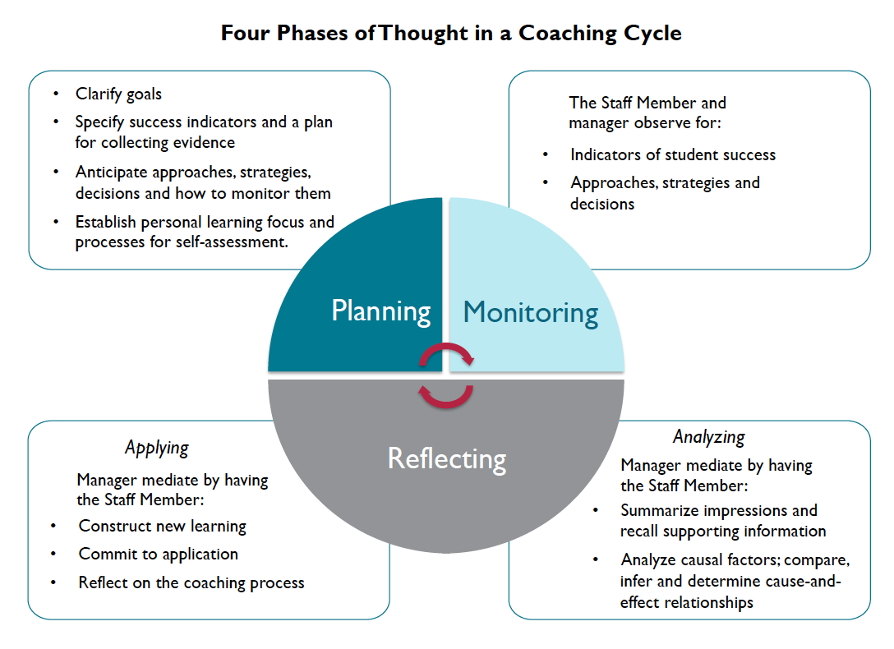

After the Observation: Leverage Leadership Coaching Structure
