Supporting Teachers of ELLs: Self-Assessment

I have worked with ELLs _____________________________________

__________________________________________________________

__________________________________________________________.

I have worked with teachers of ELLs___________________________

__________________________________________________________

__________________________________________________________.

Some successes have been__________________________________

__________________________________________________________

__________________________________________________________.

In order to support teachers of ELLs effectively, I want to know or be

able to____________________________________________________

__________________________________________________________

__________________________________________________________.

Graphic Organizer for Strategy Videos

Things I Already Do/Know | Things I Could Try/Support
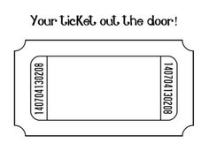

3 things you learned (optional)

2 questions (optional)

1 thing you will do

