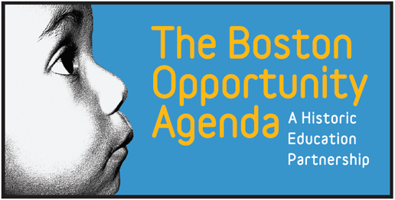
Boston Summer Learning Community Forum: Meeting the Challenge
October 22, 2015
2pm-4:30pm
Benjamin Franklin Institute of Technology

Agenda
2:05pm Introductory Remarks
Chris Smith, Executive Director, Boston After School & Beyond

2:10pm Welcome
Anthony Benoit, President, Benjamin Franklin Institute of Technology

2:20pm Presentation of 2015 Data Findings
Katie Tosh, Program Director of Measurement and Outreach, Boston After School & Beyond

3:00pm Panel Discussion and Q&A
What are the implications for summer 2016 and beyond, considering the Mayoral and Superintendent Challenge?
Moderator: Ron Fairchild, President and CEO, Smarter Learning Group
Panelists:
- Rahn Dorsey, Chief of Education, City of Boston
- Donna Muncey, Deputy Superintendent of Strategy, Boston Public Schools
- Andrea Silbert, President, Eos Foundation
- Terry K. Peterson, Director of the Afterschool and Community Learning Network. Chairman of the Afterschool Alliance. Senior fellow for policy and partnerships at the College of Charleston.
3:40pm Group Discussions and Report Outs
Shaping Summer 2016 Together
Facilitated by Ron Fairchild, President and CEO, Smarter Learning Group
4:15pm Close and Time Allocated for Individual 1-on-1 Questions for PEAR and BASB

Materials from the Forum will be posted on the Summer Insight Center at:
http://summerinsight.bostonbeyond.org/

