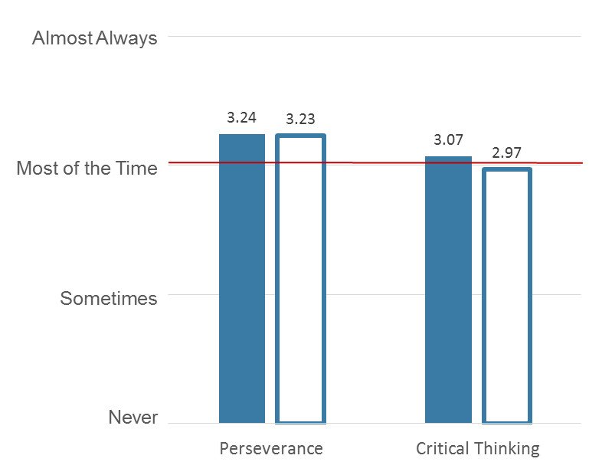
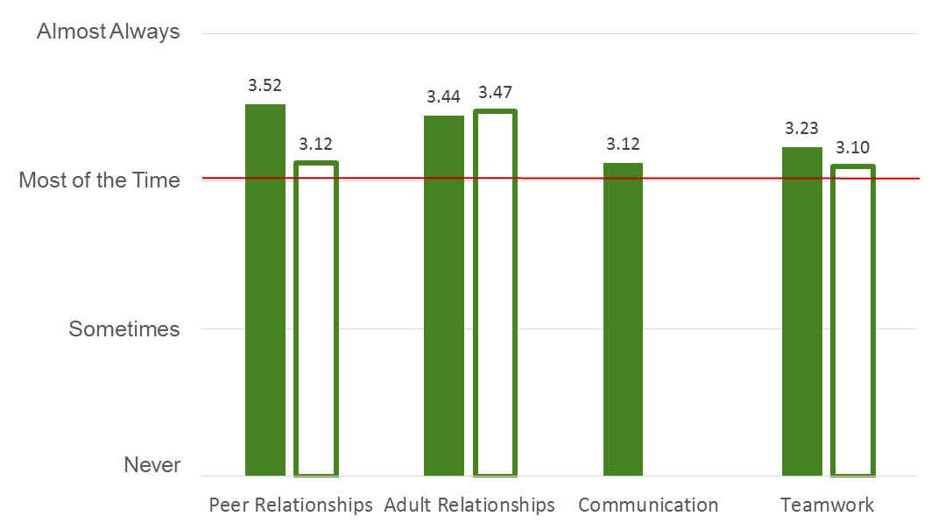
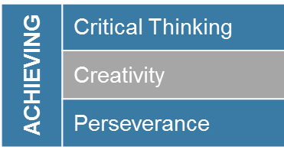
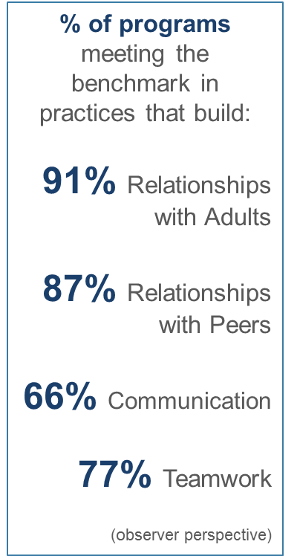
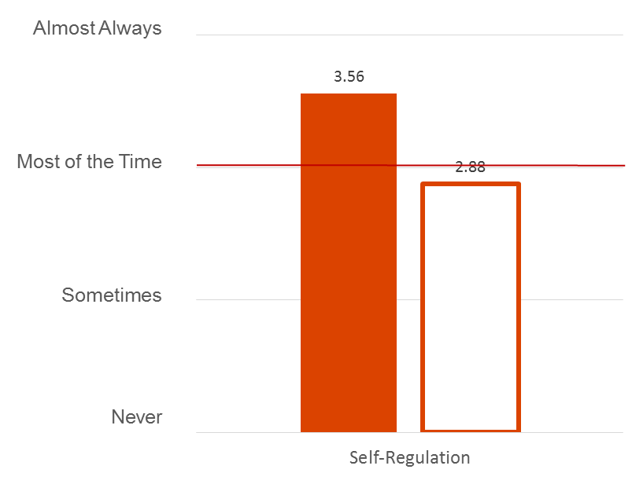
How do you help yourself Thrive?
How do you Connect to others?
How do you Achieve tasks?

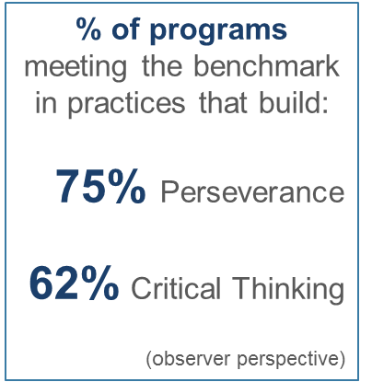
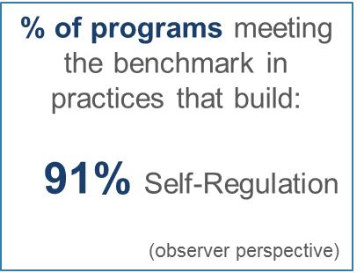
*
Program Practices Frequency with which 2016 Boston Summer Learning Community partners delivered program practices that develop ACT Skills, as rated by youth participants and external observers.
*
*

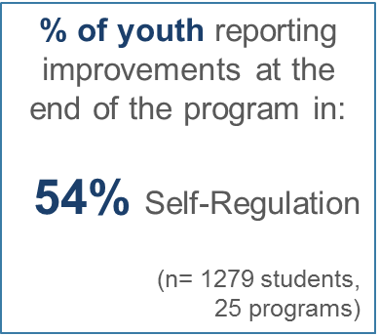
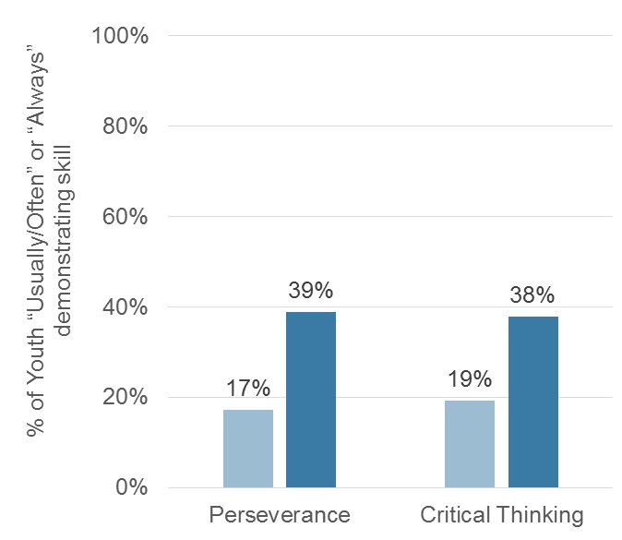
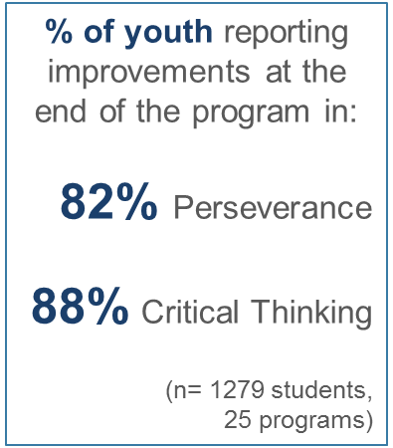
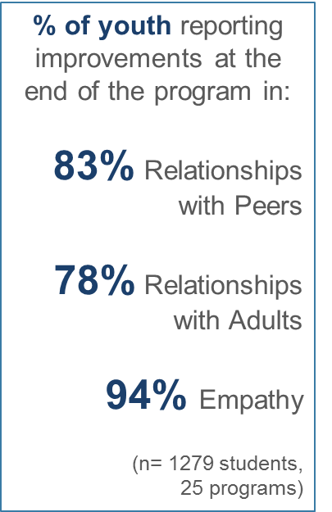
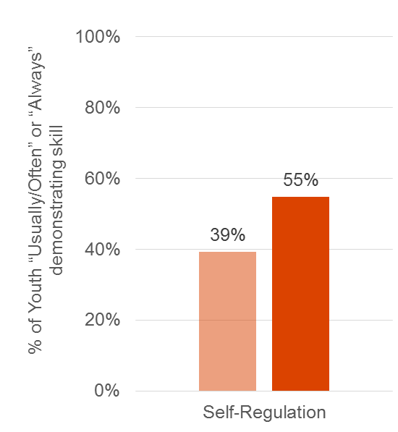
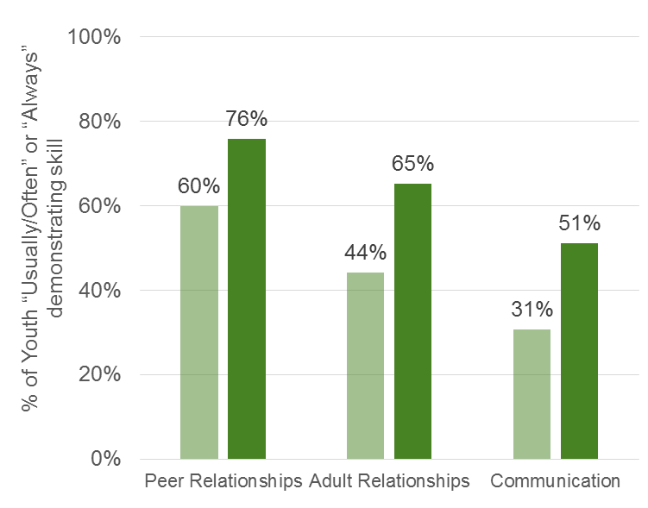

Youth ACT Skill Development Percent of participating 2016 BSLC youth meeting ACT Skill benchmark at start and end of the summer program, as rated by program staff.
Boston After School & Beyond uses measurement tools created by the NIOST, the PEAR Institute, and the Youth Experiences Survey (YES).
Intentional Program Practice Builds ACT Skills
ACT Framework |  | Definition | Examples of Intentional Program Practice
ACHIEVING | Critical Thinking | Disciplined thinking that is clear, rational, open-minded, and informed by evidence. Conceptualizing, applying, analyzing, synthesizing, and evaluating information to reach an answer or conclusion. | - Activity is challenging, stimulates thinking. Activity requires that youth learn/apply skills, solve problems, use strategy, focus and concentrate, most of the time in order to participate.  - When providing assistance to youth, staff help youth think through problems or questions themselves rather than offering answers. Staff guide youth's thinking and help them develop problem solving skills.
 | Creativity | Having originality, imagination, inventiveness, ingenuity.
 | Perseverance | The degree to which youth stay focused on a long-term goal despite obstacles, consistently performing required or important tasks and demonstrating initiative in spite of obstacles or distractions. | - The activity is part of an ongoing project, activity series or curricular unit designed to promote specific skills/concepts over time. Staff encourage individual youth. (Ex: "I like your thinking," "You can do it - give it another try.")
CONNECTING | Social Awareness & Relationships | Positive, supportive connections with friends, classmates, and adults. Social Awareness is the ability to take the perspective of and empathize with others and to understand social and ethical norms for behavior. | - Youth listen to each other. (Ex: Show interest, ask follow up questions.); Youth cooperate with each other. (Ex: Share materials/space, help each other, take turns, compromise.); Youth are kind and respectful of each other. Youth treat each other as individuals and equals. (Ex: Playful banter is always good natured.)  - Staff engage in friendly verbal exchanges with the youth. Staff show interest in youth as individuals. (Ex: Staff make a point of connecting with all youth—talk about youth’s interests, solicit youth’s thoughts and opinions on a topic.)
 | Communication | The ability to make clear and compelling oral presentations, share ideas, clarify information as needed, and adapt communication styles to meet the needs of the audience. | - Staff ask open-ended questions to facilitate youth reflection during the activity. Staff probe and extend youth’s thinking, help youth make connections, encourage youth to focus on and share what they are learning.  - Staff listen actively, attentively, and patiently to youth. (Ex: Look at youth when speaking, give youth time to express themselves, summarize back what they heard youth saying.)
 | Teamwork | The ability to work constructively and cooperatively with others. | - Activity offers youth opportunities to work collaboratively in pairs, groups or as part of a team. Youth are actively engaged in group collaboration for more than half of the time. Youth learn that working together requires some compromising, become better at sharing responsibility, learn to be patient with other group members.
THRIVING | Growth Mindset | A belief that basic qualities (e.g., intelligence, skills) can be developed and improved upon through continued learning, practice, and effort.
 | Efficacy | Self-efficacy is the belief in one’s ability to succeed in achieving an outcome or reaching a goal, which may vary across outcomes or goals.
 | Self-Regulation | The ability to regulate one’s emotions, thoughts, and behaviors effectively in different situations. This includes managing stress, delaying gratification, controlling impulses, motivating oneself, focusing on tasks, and setting and working toward personal and academic goals. | - Staff treat youth respectively, and assume best intentions. (Ex: Staff pull youth aside to discuss their behavior in private; hear youth’s point of view.) When youth behavior is inappropriate, staff use simple reminders to redirect behavior. Staff are always clam and straightforward.  - Youth learn about controlling their temper, become better at dealing with fear and anxiety, become better at handling stress, and learn that their emotions affect how they perform.
Boston After School & Beyond uses measurement tools created by the National Institute on Out-of-School Time (NIOST), the PEAR Institute, and the Youth Experiences Survey (YES). Examples of practice are pulled from the YES and NIOST tools and are used by BASB with permission.
Cross-cutting Practices Engaging youth in activities, providing opportunities for youth leadership and choice, as well as having a structured and organized program all contribute to ACT Skill development. For more information on and examples of intentional practice, including case studies, visit: summerinsight.bostonbeyond.org.

